Course Title: Social Immersive Learning
Course Code: 24UC0021
Name: L.Ishitha
Roll No: 2420030041
Section: 10

Title of the Event:
The Talent Tsunami

Organized by:
Department of Student Affairs, KLH University – Bachupally Campus

Dates:
September 10, 2025 | 9:30 AM – 4:00 PM

Event Summary:
The Talent Tsunami is an energetic and inspiring event organized to celebrate creativity, innovation, and diverse skills among students. It provided a vibrant platform for participants to express their artistic, technical, and intellectual abilities through various performances, exhibitions, and competitions. The event aimed to recognize and encourage talent across multiple domains such as art, music, dance, drama, technology, and innovation. Through this celebration, students had the opportunity to showcase their individuality, gain confidence, and appreciate the creative potential of their peers. The Talent Tsunami truly embodied the spirit of imagination, enthusiasm, and collaboration within the university community.

Key Highlights:
- Stage performances including dance, music, and drama.
- Art and innovation exhibitions showcasing student creativity.
- Interactive sessions encouraging teamwork and self-expression.
- Recognition and awards for outstanding performances and innovations.
- A platform fostering inclusivity, confidence, and artistic growth.

My Participation:
I participated in The Talent Tsunami event by attending several performances and exhibitions that highlighted the creativity and skills of my fellow students. The event inspired me to appreciate the value of art, innovation, and teamwork in personal growth. I also interacted with participants from different departments, which helped me understand how diverse talents contribute to a vibrant campus culture. This experience encouraged me to express myself more confidently and explore my own interests beyond academics.

Event Photographs:
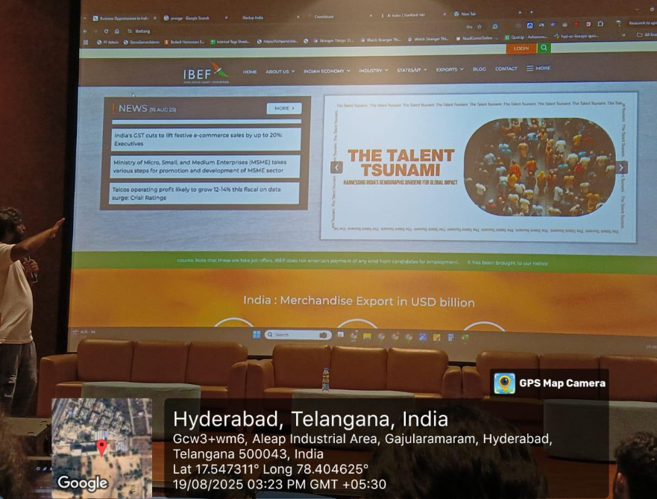

Conclusion:
The Talent Tsunami was a fun-filled and motivational event that celebrated the essence of creativity and talent. It helped students realize their potential and appreciate the importance of expressing their ideas and passions. The event strengthened our sense of community and inspired everyone to believe in their unique abilities.

Acknowledgment:
Special thanks to KLH University and the Department of Student Affairs for organizing The Talent Tsunami and providing a wonderful platform for students to express their creativity, passion, and innovation.

